24.2.21
T: Can I explain the three states of matter?
Solid | Liquid | Gas
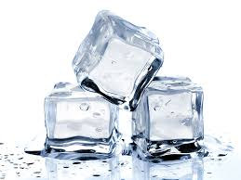  hard, firm, cold, wet, frozen, clear, transparent | 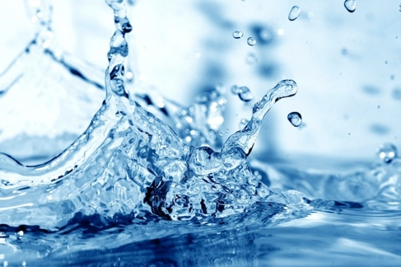  wet, warm, cold, hot, clear, transparent, still, wavy | 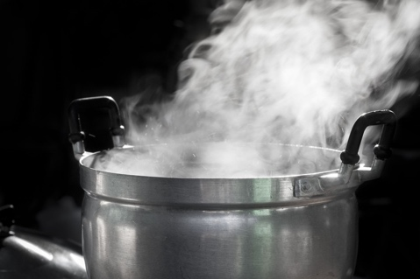  Wet, cloudy, hot, warm, thick, white
Write 3 examples of solids:  E.g. wooden table  1.  2.  3. | Write 3 examples of liquids:  E.g. orange juice  1.  2.  3. | Write 3 examples of gases:  E.g. oxygen  1.  2.  3.

Answer the questions about the different states of matter. Remember to use adjectives in your answers:

- What happens when water freezes?

- What happens when water evaporates?

- What happens when ice melts?

